Walnut wood Hutch- Great Condition - $500 or B/O. Located in Norfolk
Walnut wood construction
Hutch is 7 feet x 5 feet and 18" deep
Stained Glass
Lighting Inside Cabinets
Asking $500.00 or BO. Please let me know if you have any questions.
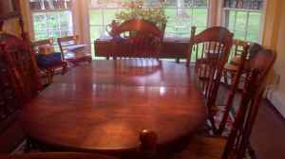 | 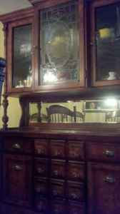
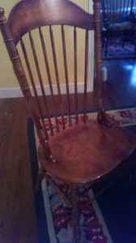 | 