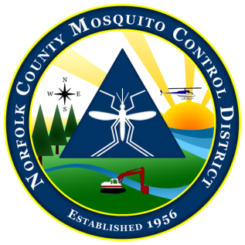
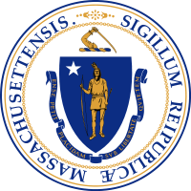

The Commonwealth of Massachusetts
The State Reclamation and Mosquito Control Board
Norfolk County Mosquito Control District
61 Endicott Street, Building #34, Norwood, MA 02062
(781) 762-3681 fax: (781) 769-6436
www.norfolkcountymosquito.org

Robin L. Chapell Norman P. Jacques Maureen P. MacEachern Linda R. Shea Richard J. Pollack, PhD
Commissioners

Caroline E. Haviland
Field Operations Manager
David A. Lawson
Director

To: Massachusetts Pesticide Board
State Reclamation & Mosquito Control Board
Boards of Health

From: David A. Lawson, Director,
Norfolk County Mosquito Control District

Date: April 4, 2014

Re: Notice of Aerial Larval Control Application

In accordance with 333 CMR 13.04 (7) (a & b), please consider this as notification of the pending aerial application targeting mosquito larvae in the wetlands in the District.

The Norfolk County Mosquito Control District will be conducting helicopter applications of the biorational larvicide Bti (Bacillus thuringiensis israelensis) to control mosquito larvae. These applications will be conducted over specific large wetlands in the Towns of:

Avon/Bellingham/Braintree/Canton/Dedham/Dover/Foxboro/Franklin/HolbrookMedfield/Medway/Millis/Milton/Needham/Norfolk/Norwood/Plainville/Quincy Randolph/Sharon/Stoughton/Walpole/Westwood/Weymouth/Wrentham.

These applications will be conducted for 2 to 3 days, anytime between April 14, 2014 and April 30, 2014. As always, the weather in the spring is unpredictable. For this reason the District cannot pin down actual application dates with any more accuracy at this time.

The trade name of the granular formulations of Bti to be used is VectoBac G (EPA Reg. #73049-10). For further information contact David A. Lawson, Director at (781) 762-3681 or the Boards of Health in the towns listed above. Information is also available on line at www: norfolkcountymosquito.org

Respectfully submitted

